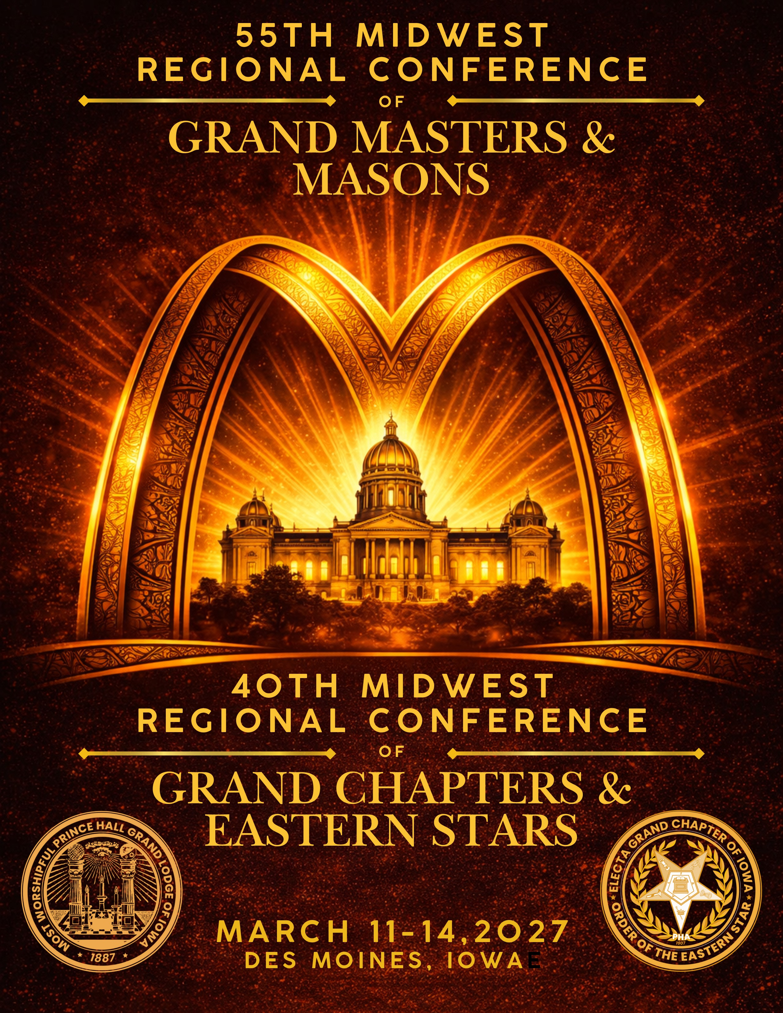

55th Annual Midwest Regional Conference of Grand Masters and Masons

Most Worshipful Prince Hall Grand Lodge Free & Accepted Masons of Iowa Honorable Jermain J. Henderson Most Worshipful Grand Master


ILLINOIS INDIANA IOWA KANSAS KENTUCKY MICHIGAN MINNESOTA MISSOURI NEBRASKA OHIO WISCONSIN
40th Annual Midwest Regional Conference of Grand Chapters and Eastern Stars
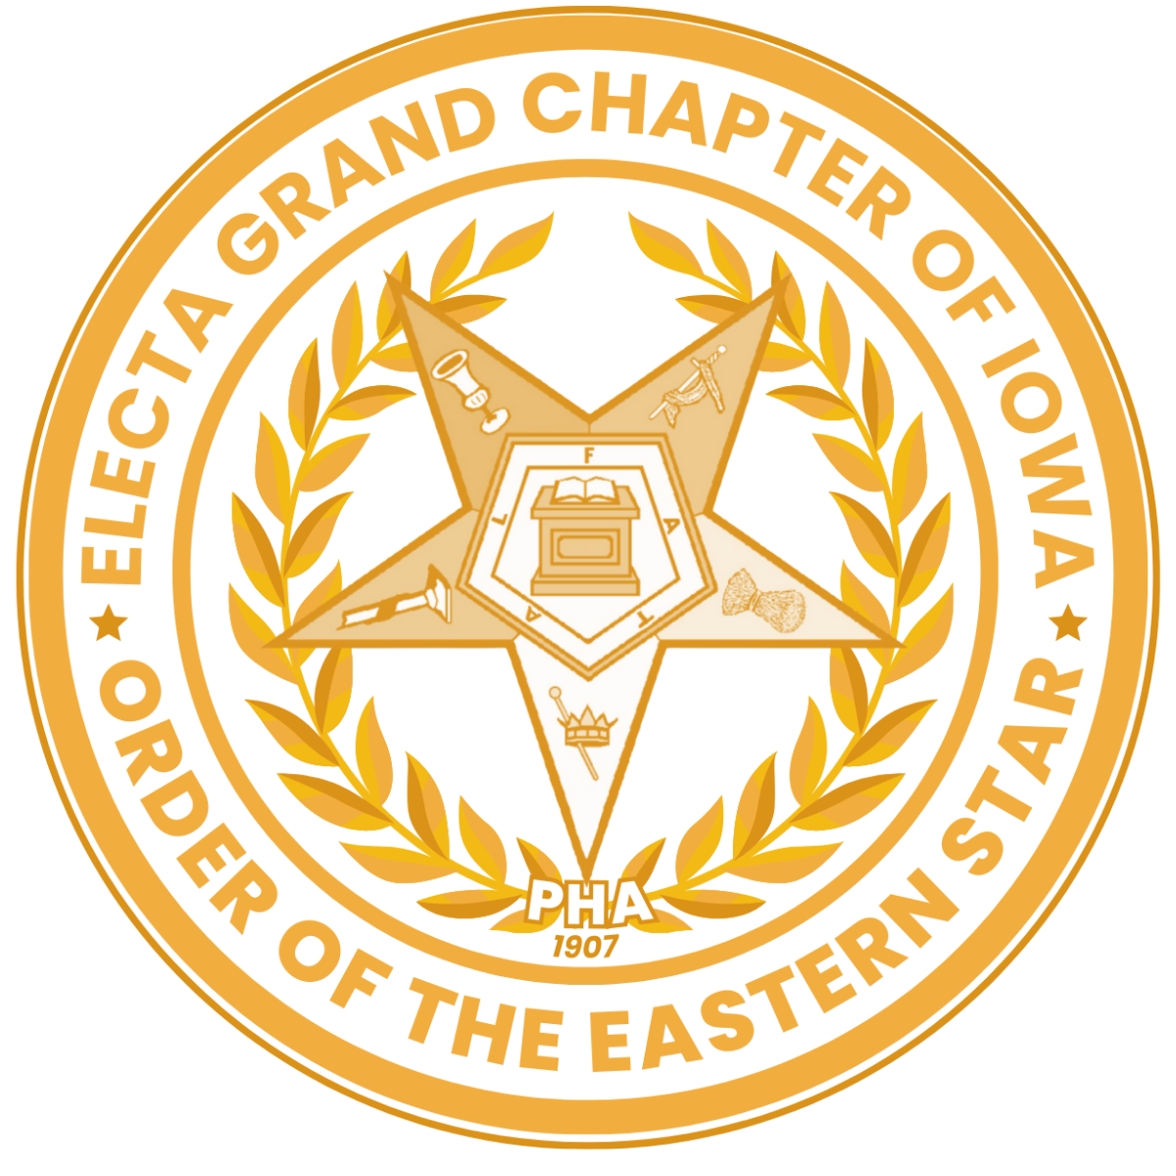
Electa Grand Chapter,
Order of the Eastern Star – PHA, State of Iowa TaRae Gardner, Grand Worthy Matron
Joshua Milam, Grand Worthy Patron

Greetings to the Most Worshipful Grand Masters, Grand Worthy Matrons and Worthy Grand Matrons, Grand Worthy Patrons and Worthy Grand Patrons, Most Worshipful Past Grand Masters, Past Grand Matrons and Past Grand Patrons, the Midwest Regional Conference Executive Staff, Delegates, and Attendees of the Midwest Regional Conference of Grand Masters and Masons and the Midwest Regional Conference of Grand Chapters and Eastern Stars.

The Most Worshipful Prince Hall Grand Lodge Free & Accepted Masons of Iowa, Inc. and the Electa Grand Chapter, Order of the Eastern Star – P.H.A., State of Iowa and Jurisdiction, Inc., cordially invite you to attend the 55th Midwest Regional Conference of Grand Masters and Masons and the 40th Midwest Regional Conference of Grand Chapters and Eastern Stars, to be held Thursday, March 11 through Sunday, March 14, 2027, in Des Moines, Iowa.

As the host jurisdiction, Iowa is honored to welcome our Prince Hall Family to our state. Iowa is home to a rich and often overlooked history of Black leadership, civic engagement, and community building. For generations, Prince Hall Masons and members of the Order of the Eastern Star have played an important role in that legacy, strengthening communities through service, education, and fellowship.
ou
Type y r text

Our planning committee is preparing a conference that reflects the fraternal spirit that defines our Prince Hall Family. We look forward to welcoming you for meaningful sessions, renewed connections, and the warm hospitality of the Iowa jurisdiction.

The enclosed packet includes information and forms for conference registration, hotel accommodations, transportation, souvenir journal advertising, and vendor registration. Please return all materials by the listed deadlines and notify the appropriate committee if you require any special accommodations, including medical, dietary, or accessibility considerations, so we may help ensure a well-coordinated conference.

We look forward to welcoming you to Des Moines as we gather in fellowship, purpose, and service for another successful Midwest Regional Conference.

Fraternally,

Eddie N. Sauls, MWPGM  Conference Chair  Most Worshipful Prince Hall GL of Iowa Phone: 515-681-7856 | Victoria Henderson Weber, PM  Registration Chair  Electa Grand Chapter of Iowa, OES, PHA Phone: 515-447-3032

MIDWEST REGIONAL CONFERENCE OVERVIEW

Hosted by
The Iowa Jurisdiction March 11 – March 14, 2027
Hotel Reservation    https://bit.ly/2027Hotel  Hotel Address  Des Moines Marriott Downtown 700 Grand Avenue  Des Moines, Iowa 50309  Hotel Reservation Phone Number  866-236-2427  Hotel Room Rate  $149 per night  use “Midwest Regional Conference” to reserve  *One night deposit is applicable when making your reservation. The first night deposit will be charged to your credit card the week of  December 10th, 2026.  Hotel Reservation Deadline  February 19, 2027 | Conference Registration    https://bit.ly/2027Midwest  Conference Registration Mailing Address  Prince Hall Grand Lodge of Iowa Attn: MWRC Registration  P.O. Box 3100,  Des Moines, Iowa 50313  Conference Registration Rate  $200  Registration Period  April 1, 2026 - February 19, 2027  Conference Registration Chair: Sis. Victoria Henderson Weber, PM 515-447-3032  princehallgrandlodgeofiowa@gmail.com

Welcome Hospitality
A Welcome Hospitality will be hosted at the hotel by the Iowa Jurisdiction on March 11th. Hospitality details will be shared upon arrival.

Parking, Transportation, and Mobility Assistance
- Valet Parking available $38/day; with in and out privileges.
- Covered garage parking available for $13/day; no in and out privileges.
- Information regarding airport transportation and mobility accommodations will be released closer to the event by Andrew Richardson, MWPGM, Transportation Chair, Phone: 563-508-9223.

CONFERENCE REGISTRATION POLICIES

Registration Requirement
All attendees of the Midwest Regional Conference must register online, request and pay an invoice, or complete a conference registration form and submit the required registration fee.

Conference Registration Fee
The conference registration fee is $200 per person and includes:
- One (1) Luncheon Ticket
- One (1) Banquet Ticket
- One (1) Special Event Ticket

Additional Event Tickets
Additional tickets for conference events may be purchased at the following rates:
- Luncheon Ticket – $50
- Banquet Ticket – $80
- Special Event Ticket – $25 Payment Instructions
- Pay online at: https://bit.ly/2027Midwest
- Request an invoice by emailing: princehallgrandlodgeofiowa@gmail.com
- Paper Registration: Checks or money orders should be made payable to:
  - MWPHGL of Iowa
Please include “MWRC” on the memo line of your payment.
  - Mail completed registration forms and payment to:
Prince Hall Grand Lodge of Iowa Attn: MWRC Registration
P.O. Box 3100
Des Moines, Iowa 50313

Registration Deadline
All conference registrations must be postmarked no later than February 19, 2027.
- No late registrations will be accepted.
- There will be no on-site registration.

Refund Policy
All refund requests must be submitted in writing to
princehallgrandlodgeofiowa@gmail.com

- Refund requests must be received no later than February 19, 2027
- No refunds will be issued after this date.

2027 MIDWEST REGIONAL CONFERENCE INDIVIDUAL REGISTRATION FORM
You may also register online at: https://bit.ly/2027Midwest

Registration forms should be postmarked by February 19, 2027 and mailed with payment to: MWPHGL of Iowa, Attn: MWRC Registration, P.O. Box 3100, Des Moines, Iowa 50313.

No late registrations will be accepted and there will be no on-site registration.

Registrant Information

Name | ​
Title/Office | ​
Mailing Address | ​
City/State/Zip | ​
Phone Number | ​
Email | ​
Jurisdiction | ​

Conference Registration

Ticket | Cost | Quantity | Amount $
Registration  (Includes 1 Lunch Ticket + 1 Banquet Ticket + 1 Special Event Ticket) | $200 | 1 | $200
Additional Luncheon Ticket(s)  Friday, March12, 2027 | $50 | ​ | ​
Additional Special Event Ticket(s)  Friday, March 12, 2027 | $25 | ​ | ​
Additional Banquet Ticket(s)  Saturday, March 13, 2027 | $80 | ​ | ​

Total Amount Enclosed ​

Arrival Date: Wednesday ☐ Thursday ☐ Friday ☐
Special Meal Requirements: Vegetarian ☐ Allergies _____________________________________ ​

Will you need transportation from the DSM Airport? Yes ☐ No ☐
Will you need mobility assistance or a scooter rental for the conference? Yes ☐ No ☐
For Committee Use: Date Received Check # Amount

Primary Contact

Name & Title | ​
Phone Number | ​
Email | ​
Jurisdiction | ​
Attendee Information

Name | Title | Airport | Mobility
​ | ​ | Y ☐ N ☐ | Y ☐ N ☐
​ | ​ | Y ☐ N ☐ | Y ☐ N ☐
​ | ​ | Y ☐ N ☐ | Y ☐ N ☐
​ | ​ | Y ☐ N ☐ | Y ☐ N ☐
​ | ​ | Y ☐ N ☐ | Y ☐ N ☐

Total Arriving Each Day: Wednesday ​ Thursday ​ Friday ​

Ticket | Cost | Quantity | Amount $ | # of Vegetarian
Registration  (Includes 1 Lunch Ticket + 1 Banquet Ticket + 1 Special Event Ticket) | $200 | ​ | ​ | ​
Additional Luncheon Ticket(s)  Friday, March12, 2027 | $50 | ​ | ​ | ​
Additional Special Event Ticket(s)  Friday, March 12, 2027 | $25 | ​ | ​ | ​
Additional Banquet Ticket(s)  Saturday, March 13, 2027 | $80 | ​ | ​ | ​

Total Amount Enclosed ​

For Committee Use: Date Received Check # Amount

2027 MIDWEST REGIONAL CONFERENCE VENDOR INFORMATION

Hosted by

The Most Worshipful Prince Hall Grand Lodge Free & Accepted Masons of Iowa, Inc. and The Electa Grand Chapter, Order of the Eastern Star – P.H.A., State Of Iowa & Jurisdiction, Inc.

Conference Information  March 11 – March 14, 2027  Des Moines Marriott Downtown 700 Grand Avenue  Des Moines, Iowa 50309  Vendor Space  Vendor space is limited and will be assigned on a first-come, first-served basis.  Vendor Setup  Registered vendors will be permitted to set up display booths on March 11, 2027.  Vendors are responsible for complying with all hotel and conference policies regarding displays, sales, and electrical use.  Vendor Refund Policy  All vendor refund requests must be submitted in writing to the Vendor Committee Chair  - Vendor Refund requests must be received no later than  February 19, 2027  - No vendor refunds will be issued after this date. | Vendor Registration  https://bit.ly/2027Midwest  Vendor Registration Mailing Address Prince Hall Grand Lodge of Iowa Attn: MWRC Vendor Registration  P.O. Box 3100, Des Moines, Iowa 50313  Vendor Registration Rate  $200  Request an invoice by emailing  princehallgrandlodgeofiowa@gmail.com  Vendor Registration Due Date  February 19, 2027
Vendor Registration Questions
For vendor questions, please contact:

RWDGM Alan Gauvin
Vendor Committee Chair
Email: agauvinjr@yahoo.com Phone: 319-361-3266

2027 MIDWEST REGIONAL CONFERENCE VENDOR REGISTRATION FORM
You may also register online at: https://bit.ly/2027Midwest

All vendor registration forms must be received by February 19, 2027, with payment to:
MWPHGL of Iowa, Attn: MWRC Vendor Registration,
P.O. Box 3100, Des Moines, Iowa 50313.

No late vendor registrations will be accepted and there will be no on-site registration.

Vendor Setup Date is March 11, 2027, at 9 AM Vendor Registrant Information
Business Name | ​
Contact Person | ​
Mailing Address | ​
City/State/Zip | ​
Phone Number | ​
Email | ​
Description of Products or Services | ​
Conference Registration

Ticket | Cost | Quantity | Amount $
Registration  (Includes 1 Vendor Table (6’) + 1Chair) | $200 | 1 | $200
Additional Table(s)  (6’) Table | $25 | ​ | ​
Additional Chair(s)  1 Chair | $25 | ​ | ​

Total Amount Enclosed ​

For Committee Use: Date Received Check # Amount

2027 MIDWEST REGIONAL CONFERENCE SOUVENIR JOURNAL INFORMATION

The Most Worshipful Prince Hall Grand Lodge Free & Accepted Masons of Iowa, Inc. and the Electa Grand Chapter, Order of the Eastern Star – P.H.A., State Of Iowa & Jurisdiction, Inc. invite you to support the 2027 Midwest Regional Conference through the purchase of an advertisement in the Official Souvenir Journal.
The Souvenir Journal will commemorate the conference and highlight the leadership, accomplishments, and partnerships that continue to strengthen Prince Hall Masonry, the Order of the Eastern Star, and the community of the entire Midwest Region.

Advertisements may be purchased by  - Grand Lodges & Grand Chapters  - Subordinate Lodges & Chapters  - Businesses and organizations  - Individuals wishing to extend greetings or recognition  Supporters are welcome to purchase multiple advertisements.  Advertisements may be submitted in the following formats:  PDF, JPEG, JPG, or PNG  High-resolution images are preferred.  If assistance is needed, please contact the Souvenir Journal Committee.  Refund Policy  No advertisement refunds will be issued.  Advertisement Submission Deadline All advertisements and payments must be received no later than  February 19, 2027 | Souvenir Journal  https://bit.ly/2027Midwest  Payment Mailing Address  MWPHGL of Iowa  Attn: MWRC Advertisements  P.O. Box 3100, Des Moines, Iowa 50313  Request an invoice by emailing  princehallgrandlodgeofiowa@gmail.com  Rates  Inside Front & Back Cover – $200 Full Page – $100  Half Page – $75 Quarter Page – $50 Business Card – $25 Ad Creation Fee – $30
Souvenir Journal Questions
For advertisement questions, please contact: Sis. Victoria Henderson Weber, PM
515-447-3032
Email: princehallgrandlodgeofiowa@gmail.com

2027 MIDWEST REGIONAL CONFERENCE SOUVENIR JOURNAL FORM
You may also register online at: https://bit.ly/2027Midwest

All Souvenir Journal forms must be received by February 19, 2027 with payment to:
MWPHGL of Iowa
Attn: MWRC Advertisements
P.O. Box 3100
Des Moines, Iowa 50313.

Please submit your print ready advertisement in PDF, JPEG, or PNG format to: princehallgrandlodgeofiowa@gmail.com

Organization

Name | ​
Contact Person | ​
Mailing Address | ​
City/State/Zip | ​
Phone Number | ​
Email | ​

Advertisement Selection

I authorize the 2027 Souvenir Journal Committee to publish the designated ad for the 2027 Midwest Regional Conference. I understand that my Ad will be published per specification listed below, and I have enclosed my payment. I understand that no late Ads will be accepted. Failure to provide payment of Ad by or prior to February 19, 2027, may cause my Ad to not be published in the 2027 Souvenir Journal.

Ticket | Cost | Quantity | Amount $
Inside Front & Back Covers | $200 | ​ | ​
Full Page | $100 | ​ | ​
Half Page | $75 | ​ | ​
Quarter Page | $50 | ​ | ​
Business Card | $25 | ​ | ​

Total Amount Enclosed ​

For Committee Use: Date Received Check # Amount

